**Project Schedule Planning** 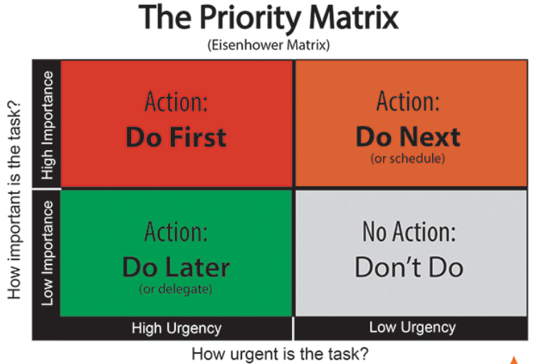

1. The Project Schedule
2. Defining Activities
3. Case study of WBS development
4. Activity definition and Task dependencies
5. Leads and lags
6. Milestones
7. Activity Sequencing
8. Gantt Chart
9. Network Diagram
10. Critical Path

**The Project Schedule**

1. A project schedule includes
   1. the sequence of activities,
   2. the duration planned for each activity, and
   3. relationships or dependencies between the beginnings and ends of different activities.
2. The project schedule is created
   1. AFTER the scope planning has been created the WBS
   2. BEFORE project resource planning

**Review: Scope Planning**

1. WBS breaks down the deliverables into smaller units, ending with the work packages.
2. A work package is a clearly defined activity or group of activities whose duration can be estimated.

**Case Study: Wedding Deliverables**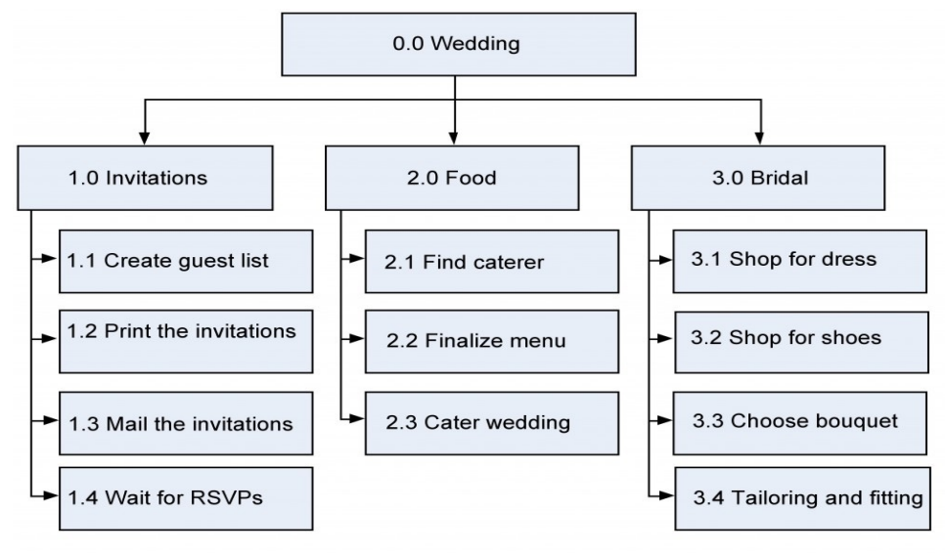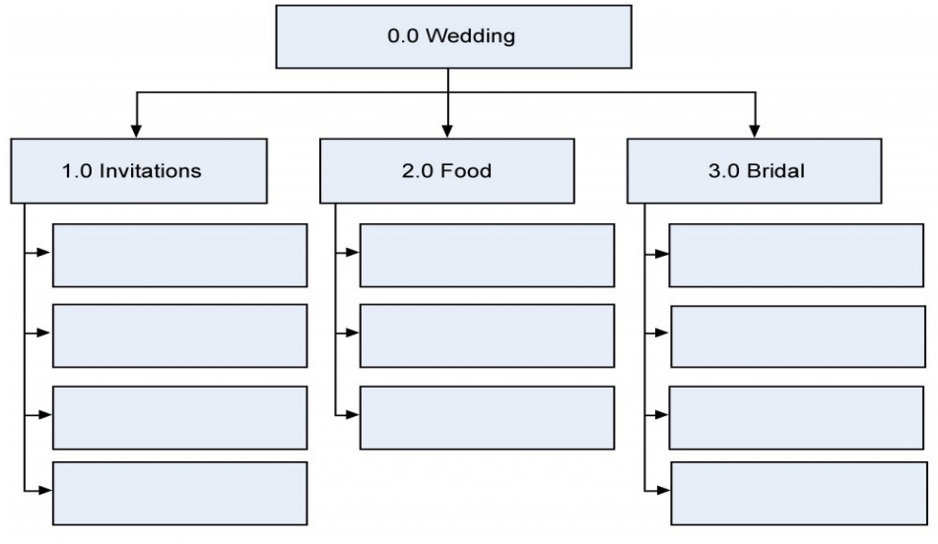

Deliverables Decompose into Work Packages

**Remember**

1. WBS follows 100% rule
2. There is no sequencing of tasks in the WBS

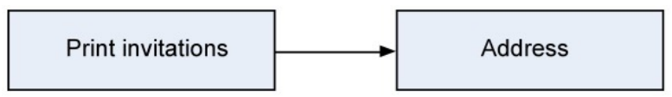

**Task Dependencies**

1. 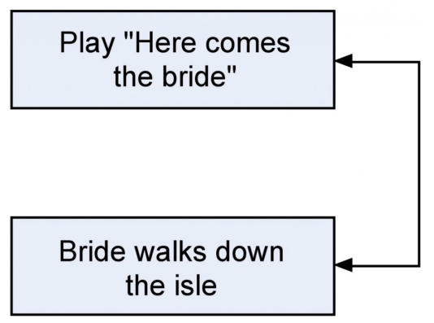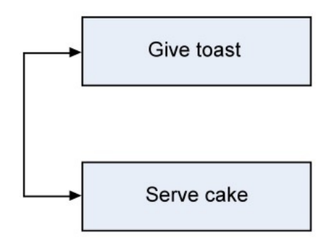Finish-to-start
2. Start-to-start
3. Finish-to-finish

**Types of predecessors**

1. External predecessors - Outside the project, such as the previous party being out of the reception hall
2. Discretionary predecessors - Matter of preference: bridesmaids arrive before a couple
3. Mandatory predecessors - Cannot do the following task until the predecessor is done: invitations must be addressed before they can be mailed

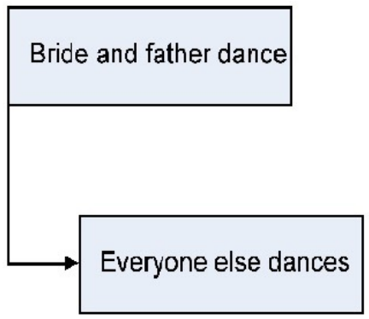

**Leads and Lags**

**Lag -** One task must wait in relation to another task

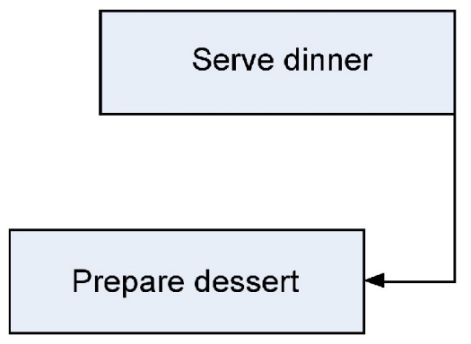

**Lead:** The task must start before the predecessor is done

**Milestones**

1. A milestone is an important checkpoint—usually the completion of a major task or a major set of tasks.
2. Target dates will be set later

**Milestones in Wedding Plan**

1. Invitations Sent
2. Menu Finalized
3. Location booked
4. Bridesmaids’ dresses fitted

**Creating a Gantt Chart**

1. Gantt Chart is a horizontal bar chart with a list of activities on the left and a timeline on the horizontal axis.
2. A traditional Gantt chart does not show dependencies; many current Gantt charts add the critical path and arrows to indicate tasks that precede other tasks.

**Network Diagram**

1. Also known as PERT chart or PERT/CPM chart
2. Illustrates task relationships
3. Used to determine the critical path
4. Software such as Microsoft Project can be used to create a network diagram.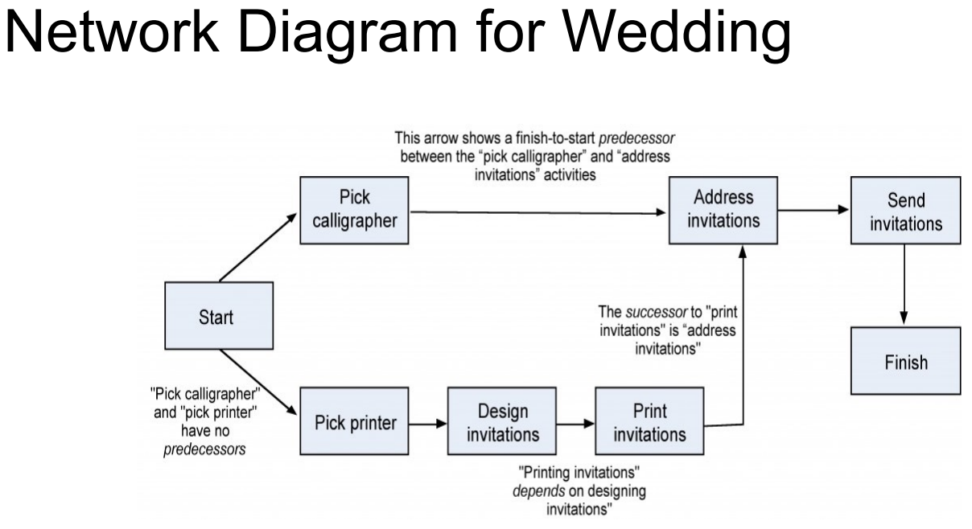

**Network Diagram: Activity on Arrow**

1. Alternative method
2. More difficult to read and understand
3. May require the creation of dummy activities when a task has multiple predecessors and multiple dependent tasks
4. More “mathematical” in its illustration of activities and events.

**The critical path**

1. When multiple paths exist through the network diagram, the path with the longest duration is called the critical path
2. If any task on the critical path is delayed, the project is delayed
3. Tasks NOT on the critical path have slack available. This is the amount of time the task could be delayed without delaying the completion of the project

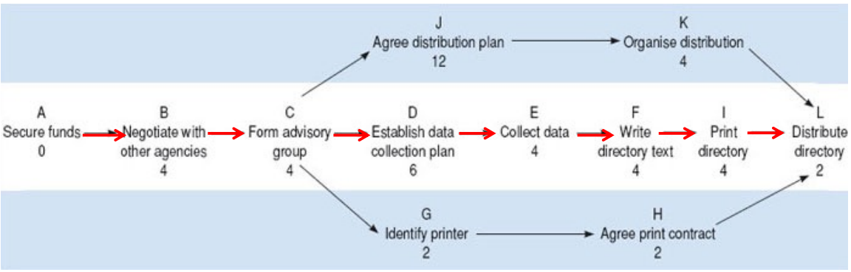

In this example the critical path is A,B,C,D,E,F,I,L, and the earliest completion date for the project is the sum of the estimated times for all the stages on the critical path – 28 weeks

**Slack**

1. Slack is the amount of time a task could be delayed without delaying the completion of the project
2. Tasks on the critical path have zero slack
3. For tasks NOT on the critical path, work backwards from the project duration to determine the amount of slack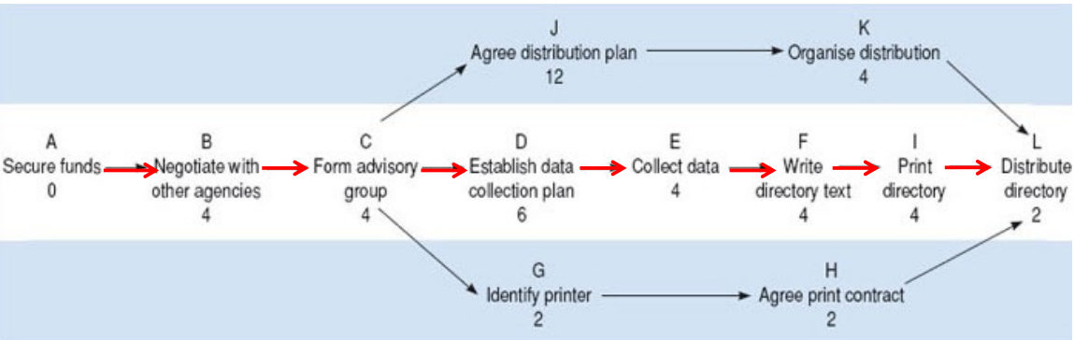

In this example, the slack for task K is 2 weeks. If task K is delayed by less than two weeks, it will not delay the completion date of the project.

**Types of Slack**

1. Total Slack - Allowable delay of activity without delaying project completion (usual meaning of “Slack” if not specified)
2. Free Slack - Allowable delay of activity without affecting the earliest start of any dependent (following) activity
3. Safety Slack - Remaining allowable delay of activity if all predecessors finish as late as possible

**Network Diagram compared to Gantt**

1. A network diagram is more technical, helps determine the critical path
2. The network diagram is not to a scaled timeline
3. Gantt is easy to read and explain to non-technical people
4. Gantt has a good method for graphically illustrating task progress and whether things are ahead of schedule or behind
5. Project managers depend on network diagrams to plan and adjust
6. Gantt is developed from a network diagram for the purpose of communicating the plan
7. Both are easily produced from project management software

**Finalizing the Project Schedule**

1. May have to negotiate with a sponsor or adjust customer expectations
2. The schedule will be impacted by Project Resource plans
3. Monitor the critical path tasks most closely

**Project Schedule Planning Summary**

1. The Project Schedule shows when each activity will take place and the dependencies between activities
2. Activities or work packages are derived from the WBS, which was developed in Project Scope Planning
3. Task dependencies may be
   1. Finish to start
   2. Start to start
   3. Finish to finish
   4. Leads and lags
4. Milestones are checkpoints
5. Activity Sequencing is determined by the dependencies
6. Gantt Chart is a horizontal timeline showing when each activity is scheduled, along with optional indicators of task progress
7. Network Diagram helps Project Managers illustrate task dependencies and determine the critical path
8. Tasks on the critical path have no slack
   1. If a critical path task is delayed, project completion will be delayed
9. Tasks not on the critical path have slack.
   1. If a non-critical task is delayed by less than the slack, project completion will not be delayed.
10. After the schedule is developed:
    1. Get approval from the sponsor; this may require some negotiations
    2. The next step will be to develop the project resource plan
    3. Project Resource Planning may cause schedule adjustments